TEMPLATES FOR ANNUAL COURSE REPORTS

University Zagazig Faculty Medicine Department Chest
Year 5th Year (2019-2020)

COURSE REPORT
A- Basic Information

1- Title and Code: Chest disease, CD CS 24
2- Programme (s) on which this course is given: undergraduate program
3- Year / Level of programme: 5th yr (2019-2020)
4- Units / Credit hours:
Lectures 192 hrs Tutorial/Practical 128 hrs Total 320. hrs.

5- Names of lecturers contributing to the delivery of the course
………….All staff members of the department…………
- Course coordinator: Chairman Prof. / Mostafa Ragab
- External evaluator (s):

B- Professional Information
1-Course teaching: All staff members were included in the course of teaching
A) THEORETICAL TOPICS:
Topics actually taught | No. of hours
Anatomy and Physiology | 2 hours
Bronchial Asthma | 2 hours
COPD | 2 hours
Pulmonary tuberculosis | 2 hours
Pulmonary tuberculosis | 2 hours
Pneumonia(bacterial viral, fungus & parasitic) | 2 hours
Suppurative Lung diseases | 2 hours
I.L.D + Occupational lung disease | 2 hours
Pleural diseases | 2 hours
Lung cancer + Mediastinal syndrome | 2 hours
Pulmonary Embolism+ Life Threatening conditions | 2 hours
X-ray. ABG. Pulmonary function And MCQs | 2 hours

B) CLINICAL /PRACTICAL TOPICS:
Topic actually taught | No. of hours
1) Personal history, complaint, present history (symptomatology of chest diseases (Dyspnea,Cough, expectoration & haemoptysis chest pain, chest wheezes), past & family history) | 2
3) General examination | 2
4) Inspection &Palpation | 2
5) Percussion | 2
6) Auscultation | 2
7) Research evaluation | 2
8) X-ray & Pul function | 2
9) Living museum | 2

Topics taught as a percentage of content specified
> 90% ✓✓✓ 70-90% ………… < 70% …………
- Reasons in detail for not teaching any topic
……… NO………..
If any topics were taught which are not specified, give reasons in detail
……….. NO ……………

2- Teaching and learning methods: (please tell yes or no)
Lectures: ……… Yes …………..
Practical training/ laboratory: ……… Yes …………….
Seminar /workshop: ………… NO ……………….
Class activity: ……… Yes…………………
Case study: ……… Yes ………….
Other assignments/ homework: …………………..
If teaching and learning methods were used other than those specified, please list and give reasons:
…………………………………………..
…………………………………………

3- Student assessment:

Examination | Description | Marks
End of the round | Clinical and radiological MCQs | 3(20%)
End of the round | Log Book& Research | 1.5(10%)
End of the round | OSCE | 6(40%)
End of the round | Attendance (Clinical &theoretical) | 1.5(10%)
End of the round | Theoretical MCQ | 3(20%)
TOTAL |  | 15 Marks

Members of examination committee:
All staff members of the chest department.

Role of external evaluator:
Evaluation and revision the course

4- Facilities and teaching materials: (Please tell yes or no)
Totally adequate: …………………….
Adequate to some extent ✓✓✓
Inadequate ……………………………..
List any inadequacies:
*Data show wasn't available in all lecture halls.
*Times of lectures weren't suitable
* Stimulator models for clinical exam

5- Administrative constraints
List any difficulties encountered
- After increased numbers of Covid-19 cases, Study was interrupted for long period.
- Difficulties in students attendance to prevent spread of infection leading to difficulties in practical Topics teaching and in students Assessment
- Our sharing marks in the final exam is too small comparing with the total number of examination marks.
- No sharing in the final written exam.

6- Student evaluation of the course:
List any criticism | Response of course team
•Study was interrupted for long period. | • Delay Final exam date  • Compression of lectures
• Difficulties in students attendance | • Online lectures
• Difficulties in students assessment esp in practical topics | •The last 5 groups assessed by MCQs and Research only
•Lack of good ventilation in lecture halls | • Requesting the authorities for supplying the department with air conditioners & fans.
7- Comments of staff:

Comments | Response of course team
• Large number of students in each goup | • Divide group to smaller groups  • Activate online lectures
•Times of lectures weren't suitable | •Requesting new schedules with suitable times
• Inadequate teaching facilities | • Request for their supply

8- Comments from external evaluator(s):
Comments | Response of course team
• Short time of theoretical lectures | • Request to increase that time

9- Course enhancement:
Progress on actions identified in the previous year’s action plan:
Action | Completed  (yes or no) | Reasons for non-completion
Increase Teaching materials and facilities | yes
Increase knowledge about infection control methods | Yes
Prolongation the time required for clinical rounds | No | As there is limited time table for lectures

10- Action plan for academic year 2020-2021y
Actions required | Completion date | Person responsible
Decrease number of students in each group | During clinical round
Activate Online Lectures | At the start of this academic year

C- Statistical Information 2019/2020
Appendix I “ For continuous assessment” :
No. of students attending the course: No. 1090 100%.
No. of students completing the course: No 1051 96.4%.

Appendix II “ For final assessment ” :
- Results:
Passed: No. 1042 99.1%.
Failed: No. 9 0.85%.

- Grading of successful students:
Excellent: No. 965 91.7 %.
Very Good: No. 65 6.1%.
Good: No. 17 1.6%.
Pass: No. 1 0.09%.

Course coordinator …………………..
Signature ……………………….
Date: / /

درجات أعمال السنة(20%) فى الأمراض الصدرية لطلاب الفرقة الخامسة 2019/2020للعام الدراسى
نسبة الحضور والغياب

Absentism | No. of students completing the course | Total No. of students
39 | 1051 | 1090

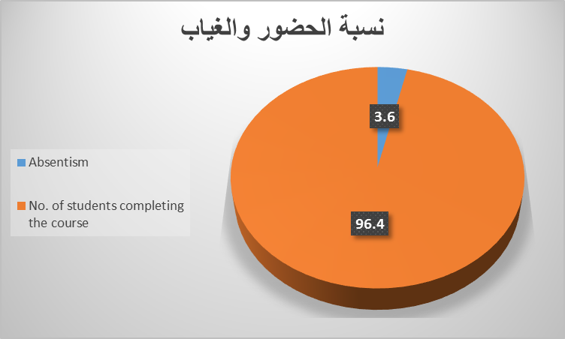

نسبة النجاح والرسوب

Passed students NO (%) | Failed students NO (%)
(99.1%) 1042 | (0.85%) 9

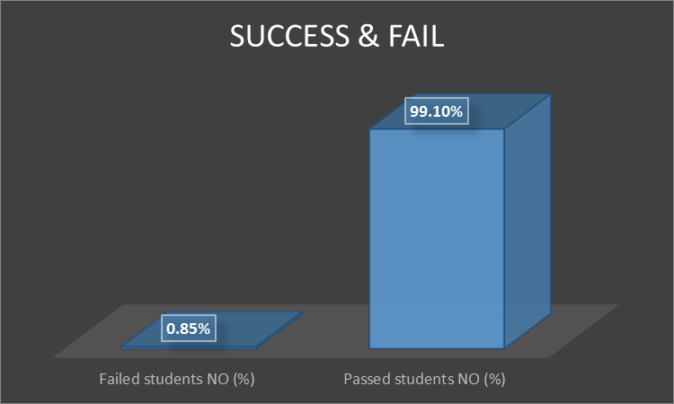

التقديرات المختلفة للناجحين

Pass No (%) | Good No (%) | Very Good No (%) | Excellent No (%)
1 (0.09%) | 17 (1.6%) | 65 (6.1%) | 965 (91.7 %)

