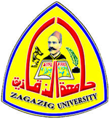 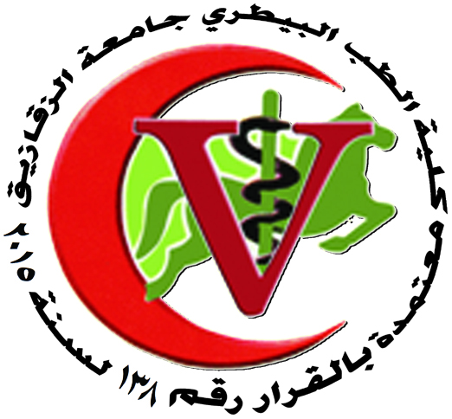

**Zagazig University**

**Faculty of Veterinary Medicine**

**Pharmacology** **Department**

**List of National publications**

1. Rasha T M Alam and Azza A A Galal (2013): Clincopathological Studies On Hepato-Nephro-Protective Effect Of Salvadora Persica Extract In Albino Rats: Zag. Vet. J. (ISSN. 1110-1458) Vol. 41 No. 5 pp 8-19.
2. Abdelaziz SA, Said AA, Edres NO and Amer GA(2013): The IMMUNOMODULATORY EFFECTS OF ORAL ADMINESTRATION OF AZITHROMYCIN AND Echinacaaaae spp in pasteurella multocida vaccinated rats: Zag. Vet.j. Vo. 41 No. 1
3. Hosney Abd EL Fadil, Sawsan El Skeik, Emam EE and Morsy Mater(2013):Efficacy of boldenone undecylenate and propiotic as growth promoters on male bufflo calves : Zag. Vet.j. Vo. 41 No. 1
4. Sawsan M A El Sheikh, Hosney A E Ibrahim, Refaat K MOHAMED and Dalia I M Ibrahim (2013): EFFECT of propolis , florfenicol, and their combination on cat fish (clariaz lazara) experimentally infected with Aeromonas hydrophila: Zag. Vet.j. Vo. 41 No. 2
5. Aziz S A, Said A A, Kamel MA, Abdel Aziz AM and Amal S Hamdy(2013):Pharmacological effects of ceftifur sodium in the presence of saccharomyces in broiler chicken: Zag. Vet.j. Vo. 41 No. 4
6. Kamel M.A. (2014): Protective effects of marjoram oil (organium majorana l.) on antioxidant enzymes in experimental diabetic rats. Assiut Vet. Med.J. vol. 60 no. 140
7. [Magdy F. Abou El Fotoh](http://www.researchgate.net/researcher/2047905640_Magdy_F_Abou_El_Fotoh), Kamel M.A, [Nora E. A](http://www.researchgate.net/researcher/2047884084_Nora_E_A), [Magda Hassan](http://www.researchgate.net/researcher/2047912396_Magda_Hassan) (2014): [Immunosuppressive Toxic Effects of Ochratoxin A in Mature Male Albino Rats](http://www.researchgate.net/publication/262169676_Immunosuppressive_Toxic_Effects_of_Ochratoxin_A_in_Mature_Male_Albino_Rats).Scientific Journal of October 6 University. 01/2014;
8. Kamel M.A. and Noha A. Beder (2012): Levamisole; how eeffective could be in foot-and-mouth disease (afield trial) 15 Sci. Cong. . Fac. Vet. Med. Assuit Univ. Egypt 73-87.
9. Magdy F. Abou El Fatoh, Kamel M. A., Nora E. Abdel Hamid and Magda Hassan: Immunosuppressive toxic effects of ochratoxin a in mature male albino rats. Scientific Journal of October 6 University 2 (2): 174-179.
10. Aziz S.A., Said A.A., Kamel M.A., Abdel Aziz A.M. And Amal S. Hamdy: Pharmacological effects of ceftiofur sodium in the prescence of saccharomyces in broiler chicken. Zag. Vet. J. (ISSN. 1110-1458) Vol. 41 (4) pp 179-191.
11. Mohamed A.E. Omar, Kamel M.A. and Ali M. A.Economical and Immunological Evaluation of Probiotic (L. acidophilus) In Male Castrated Goats within Egypt. Life Science Journal (2014). 11 (IX).
12. Kamel M.A. and Hosny Abdel Fadil I. and Noha M.A Prevention of Hepato-renal toxicity with Vitamin E, Vitamin C and their combination in Gentamicin treated rats.
13. Hosney Abd EL Fadil, Sawsan El Skeik, Emam EE and Morsy Mater(2013):Efficacy of boldenone undecylenate and propiotic as growth promoters on male bufflo calves : Zag. Vet.j. Vo. 41 No. 1
14. Sawsan M A El Sheikh, Hosney A E Ibrahim, Refaat K MOHAMED and Dalia I M Ibrahim (2013): EFFECT of propolis , florfenicol, and their combination on cat fish (clariaz lazara) experimentally infected with Aeromonas hydrophila: Zag. Vet.j. Vo. 41 No. 2
15. Aziz S A, Said A A, Kamel MA, Abdel Aziz AM and Amal S Hamdy(2013):Pharmacological effects of ceftifur sodium in the presence of saccharomyces in broiler chicken: Zag. Vet.j. Vo. 41 No. 4

16. Hosny A Ibrahim, Naglaa ZH Eleiwa, Azza AA Galal, Walaa El-Ekiaby, El Sayed Abd El Rahman(2020): Antibacterial Activity of Doxycycline against Aeromonas hydrophila in Experimentally Challenged African Catfish (Clarias gariepinus

17.Gamal Shams; nagah mohamed; elham mobarez; sara abd el wahab(2019): Residues of Diclofenac Sodium in Rabbit Tissues

18. Asmaa Abd El-Monsef; Sawsan El-Sheikh; Naglaa Eliewa; Mohamed Khairy; Osama Abdalla(2019): Effect of Antibiotics Growth Promoters Alternatives on Growth Performance, Hematobiochemical and Immunological Profile of Healthy Broiler Chickens

19. Sameh El Nabtity; Ahmed Abdel-Aziz; manar Moselhi(2019): Anticonvulsant and GABAnergic Activity of Nigella sativa oil in Mice