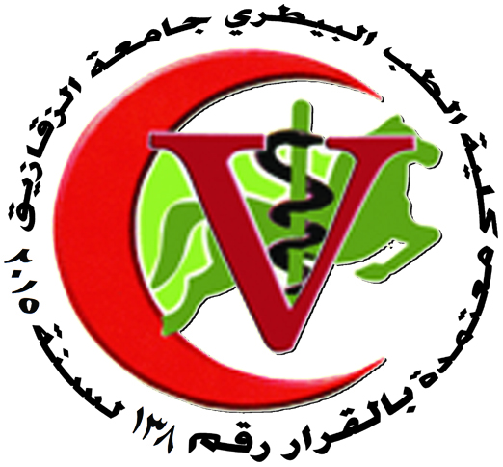 | 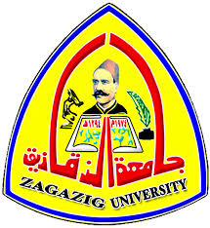
Zagazig University
Faculty Of Veterinary Medicine
Department Of histology and cytology
Master thesis
Date | Supervision committee | Thesis tittle | Student name
23/3/2017 | Prof.Dr/waheed Abdel-Azim  Prof.Dr/ Mohammed H.bareedy  prof. Dr/ Ahmed Mustafa baleh | Light and electron studies on the uterine tube of goat (capra hircus) | Maha sabrey Elsayed

Head of the department
Shafika Abdelrahman

