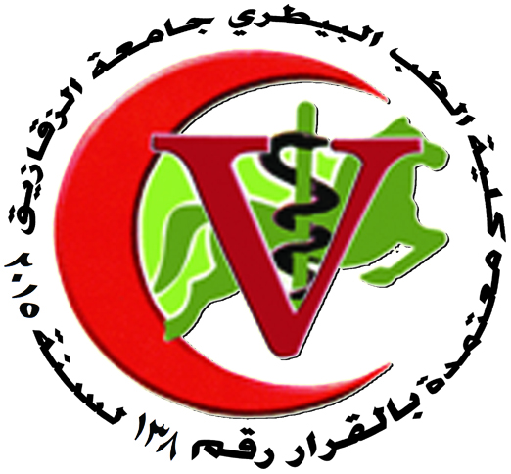 | 
ZAGAZIG UNIVERSITY
FACULTY OF VETERINARY MEDICINE
DEPARTMENT OF PATHOLOGY

ORGANIZATIONAL CHART
STAFF MEMBERS
Mobile | E. mail | Position | Name
01005043940 | Abdelmoneim.ahmedAli@yahoo.com | Professor & Head of pathology Department | Prof. Dr. Abdelmoneium ahmed ali
01229657109 | magdykadr@hotmail.com | Professor | Prof. Dr. magdy hassan fekry
01092900556 | mohkayzy@hotmail.com | Professor | Prof. Dr. Mahmoud fawzy Mahmoud fahmy
01224064836 | d.sleem@yahoo.com | professor | Prof.Dr. mostafa selim abo elfetoh
01110632820 | Syedattar57@yahoo.com | professor | Prof .DR. said Rashad el attar
01111037494 | Nahla-Kashmery@hotmail.com | professor | Prof . Dr. Nahla abdel gaffar ahmed
011556507780 | nouraelseddawy@yahoo.com | Lecturer | Dr. noura mohammed abel azezz
01151753706 | Hoba-vet@yahoo.com | Lecturer | Dr. heba mohammed abdel ganny

STAFF MEMBERS’ ASSISTANT

Mobile | E. mail | Position | Name
01151489639 | @yahoo.commohamedsobh89 | Assistant lecturer | Vet. Mohammed salah ahmed sobh
--- | ---- | Demonstrator | Vet. Aya samy elsaid

Head of the Department

Prof. Dr.Abdelmoneium ahmed ali

