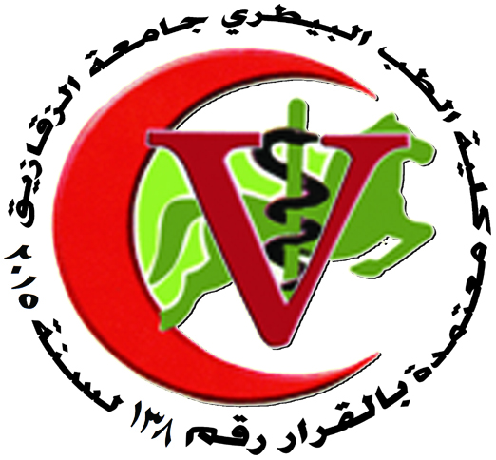 | 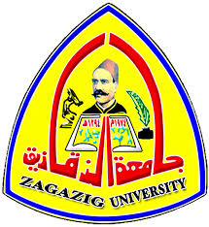
ZAGAZIG UNIVERSITY
FACULTY OF VETERINARY MEDICINE
DEPARTMENT OF VETERINARY PUBLIC HEALTH

ORGANIZATIONAL CHART
STAFF MEMBERS
Mobile | E. mail | Position | Name
0100717248 | mzead48@yahoo.com | Professor & Head of vet. Public health Department | Prof. Dr./ Mohamed Youssef Ibrahim Youssef
 |  | Professor | Prof. Dr./ Mahdy Abd El-Gawad Abd El-Kader
 |  | Professor | Prof. Dr./ Mahmoud samy Ahmed
01285539385 | hrahaf59 @ yahoo.com | professor | Prof. Dr./ El Sadik Khalil Youssef
01003392084 | Amr.abdel74@ yahoo. Com | professor | Prof. Dr./ Amro Mohamed Mohamed
01098002665 | Hesham hosny@yahoo.com | professor | Dr./ Hesham Hosny El sayed Mohammed
01066570555 | Dr_Hisham2001@yahoo.com | Assistant professor | Dr./ Hesham Mohamed El Sayed
01228082193 | Megahed330@yahoo.com | Assistant professor | Dr/ Ayman Mohamed Megahd
01285293730 | azharfakhry65@yahoo.com | Assistant professor | Dr./ Azhar Fakhry Abd-Elfatah
01146142662 | enasnassef5@gmail.com | Assistant professor | Dr./ Enas Nasef Said
01120136613 | mhkhedr@yahoo.com | Assistant professor | Dr.mariam hassan elbana khedr
01208790777 | shereen-mk@hotmail .com | Assistant professor | Dr./ Shereen El Sayed Mohamed Abdel -hamid
01227986379 | Vetdr-ehab83 @ yahoo. Com | Assistant professor | Dr./ Ehab El- sayed Nabawy
01152808050 | Amy_talat20002@yahoo.com | Assistant professor | Dr./ Amira Samir Atia
01068189640 | Dr_heba_vet@yahoo.com | Lecturer | Dr/ Heba Said Abd el Rahman
01023421757 | Dr.mai151.mf@mmail.com | Lecturer | Dr: Mai farag ibrahim
01273415808 | asmaaibrahimvet@gmail.com | Lecturer | Dr: Asmaa Ibrahim abdel- aty

STAFF MEMBERS’ ASSISTANT

Mobile | E. mail | Position | Name
01060153067 | Fayyad 568@gmail.com | Assistant Lecturer | Vet. Fayza Abd Allah Ahmed
01211450353 | Mmosalim@vet.zu.edu.eg | Assistant Lecturer | Vet. Manal Ali Mesalam
01014596105 | Hesraa907@gmail.com | Demonstrator | Israa hisham mohamed
01229432115 | Nagwangamal364@gmail.com | Demonstrator | Nagwan gamal abdel-menom

EMPLOYEES

Mobile | Position | Name
01140422420 | Store kepper | Mr.El Shahat Mahmoud Hessin

Head of the Department

14-3-2021م Prof. Dr. Mohamed Youssef Ibrahim

