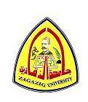 |  |  |  |  |  |  | 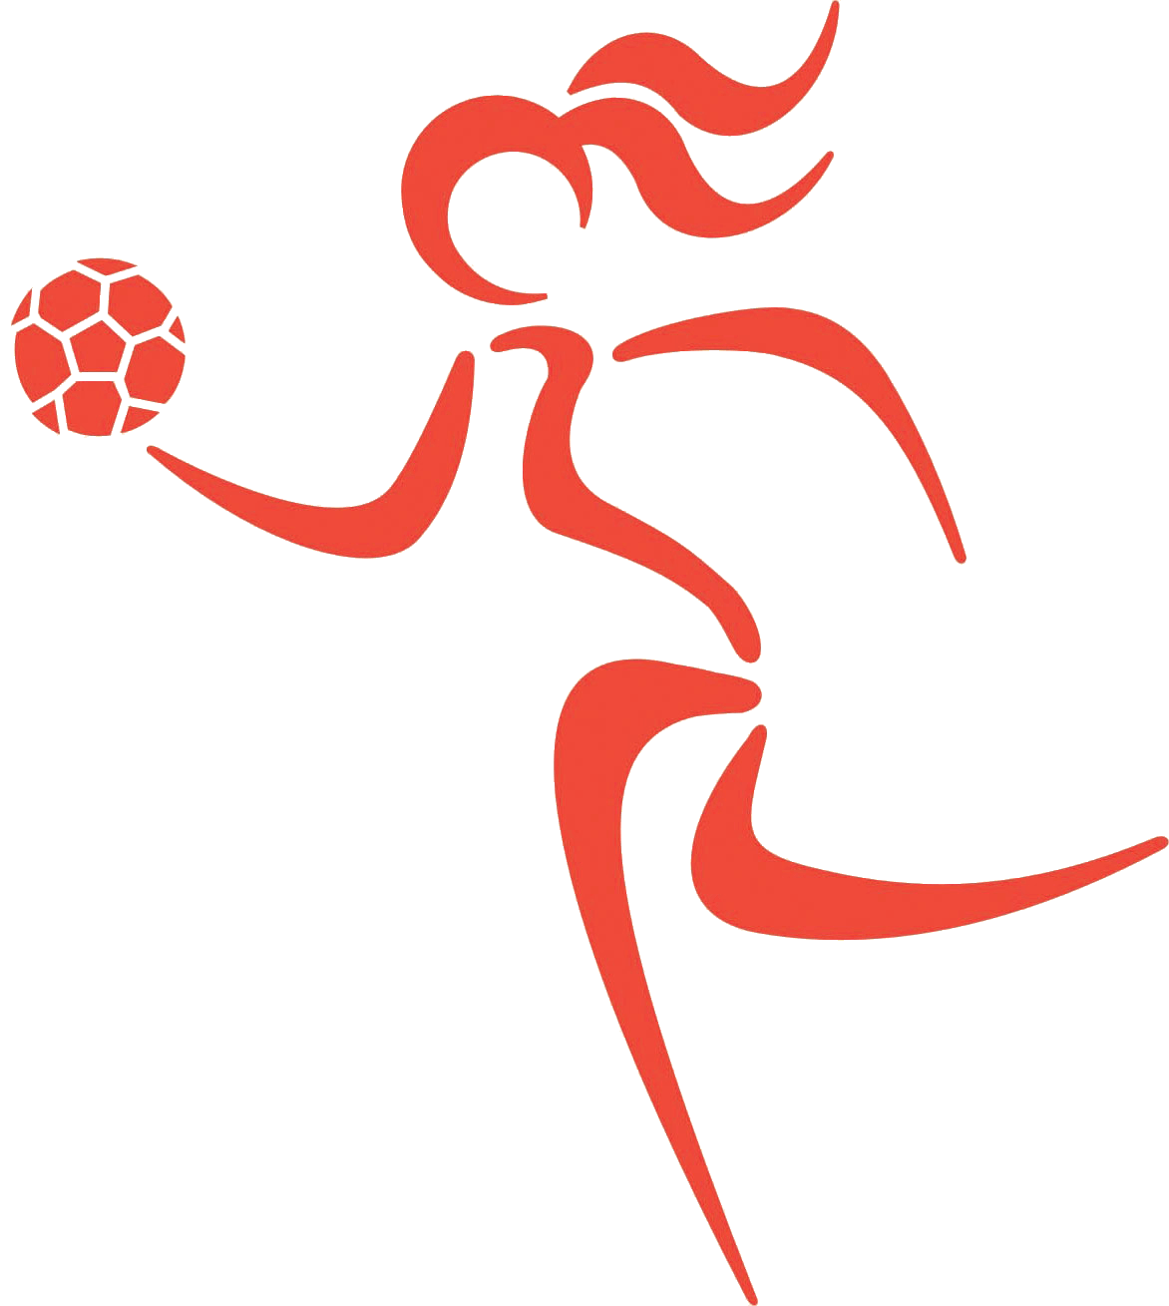
Date: 4-1-2016. |  |  |  |  |  | Zagazig University.
Second year. |  |  |  |  | Faculty of physical
English Language. |  |  |  |  |  | Education For Girls.
Time: 2 hrs. |  |  |  |  |  | Total Mark : (60) Marks.
First term. |  |  |  |  |  | No. Question : (4).

-Answer all the following questions:

Q1.Read the following passage and answer the questions:-(12 Marks):-
Handball is a team sport in which two teams of seven players each (six outfield players and a goalkeeper) pass a ball to throw it into the goal of the other team. A standard match consists of two periods of 30 minutes, and the team that scores more goals wins. Modern handball is played on a court 40 by 20 meters (131 by 66 ft), with a goal in the center of each end. The goals are surrounded by a 6-meter zone where only the defending goalkeeper is allowed; the goals must be scored by throwing the ball from outside the zone or while "diving" into it. The sport is usually played indoors, but outdoor variants exist in the forms of field handball and Czech handball (which were more common in the past) and beach handball (also called sand ball). The game is quite fast and includes body contact, as the defenders try to stop the attackers from approaching the goal. Goals are scored quite frequently; usually both teams score at least 20 goals each, and it is not uncommon for both teams to score more than 30 goals.
Answer the following questions:

1-What is hand ball?

2-What is the period of hand ball match?

3-What are the characteristics of the court?

4-How are the goals are scored?
- Handball is a team sport in which two teams of seven players each (six outfield players and a goalkeeper) pass a ball to throw it into the goal of the other team.
- A standard match consists of two periods of 30 minutes, and the team that scores more goals wins.
- Modern handball is played on a court 40 by 20 meters (131 by 66 ft), with a goal in the center of each end. The goals are surrounded by a 6-meter zone where only the defending goalkeeper is allowed.
- The goals must be scored by throwing the ball from outside the zone or while "diving" into it.

Q2 Write a paragraph of not less than 10 lines on (How can you benefit from your studying for physical education in your practical life):-(10 Marks)
حسب إجابة كل طالبة
Q3.Grammar and structure:-(20 Marks):-
(Allow - vices) | 1- Give the opposite of the following words:-
(Correct the verb) | 2-Last year Mr. Ahmed (teach) us English
(Correct the verb) | 3-What you (watch) now?
(Correct the verb ) | 4-Every week our cousins (invite) us to tea.
****باقي الاسئلة بالخلف***

(Correct the verbs) | 5-While she (walk) she (meet) her mother.
(Ask a question) | 6-Thirty boys are in the class.
(Correct the word) | 7-She is (bad) than her sister.
(Negative) | 8-She brought everything from the market.
(Negative) | 9-She loves him.
( Ask with How long) | 10-Mr. Ali stayed in London for six months.
1-Forbid - virtues.
2- Last year Mr. Ahmed taught us English.
3-What are you watching now?
4- Every week our cousins invite us to tea.
5- While she was walking she met her mother.
6-How many boys are in the class?
7- She is worse than her sister.
8- She brought nothing from the market.
9-She does not love him.
10-How long did Mr. Ali stay in London?
Q4.Translate into English:-(18 Marks):-
- الرياضه هي الصحه فلابد من ممارستها كما انها غذاء الروح وعند ممارسة اي نوع من الرياضه لابد من احترام قوانينها وتطبيقها على اكمل وجه وعدم تعرض الفرد الى ما يسمى مسلك غير رياضي يعاقب عليه في النهايه وقد تكون نهايته الاستبعاد او ربما الطرد ولا بد من الاعب ان يتحلى بما يسمى التروي والصبر والروح الرياضيه.
- الرياضه هي عباره عن حركات منتظمه يقوم بها الفرد للوصول الى مايسمى بالاداء الصحيح الذي يحتوي على جميع عناصر اللياقه البدنيه والهدف هو تحقيقها كا التوازن والرشاقه والدقه والقوه والمرونه ايضا وهي تسعى الى تحقيق التوازن مابين الجانب النفسي والعقلي والبدني ولكي يتحقق التوافق العضلي والعصبي في الجسم لا بد من توافق الجوانب التي ذكرت .
- التمرينات الرياضية تساعد أجهزة الجسم الحيوية على العمل بكفاءة عالية، فضلا عن الصفات الترويضية للجسم و العقل كما أن القيادة الجماعية في الملعب تكسب الإنسان الدقة والعمل و الثقة بالنفس.
1-Sport is health so it must be practiced , also it is a soul food and in practice any kind of sport it has to be respect its laws and apply them with the best way so man do not act with non sport way to do not lead him to punish at the end or may it lead to have exclusion or perhaps expulsion and the player should possess what is called prudence, patience and sporting spirit.
2-Sport is a regular movements performed by a man to get to what is called right performance which contains all the physical fitness elements , and the goal is to have a balance , agility , accuracy, strength and also flexibility it also seeks to achieve balance between psychological, mental, and physical aspects and to achieve muscular and nervous co ordination in the body , it must to co ordinate the mentioned aspects.
3-Sport exercises help the vital organs to work efficiently as well as taming qualities of the body and the mind , and the collective leadership in the field earn accuracy , work and self – confidence to the man.
ترجمي الكلمات الآتية الى الانجليزية :-
شد عضلي - إنبطاح - مفصل الفخذ - عضلة القلب - التواء– مستوي الاداء .
Muscle strain - supination - hip joint - myocardium - flexion - performance level.
Translate into Arabic:-
- The key rule of volleyball is to keep the ball in the air and could be hit with any part of the body. A maximum of three hits are only possible on each team to get the ball to the other side. The other rules of the game would include things like; no player can hit the ball twice consequently. A point would be gained when one of the team plays the ball on the opponents court and the ball not being defended.
- Gymnastics involves the women's events of uneven bars, balance beam, floor exercise, and vault. Men's events are floor exercise, pommel horse, still rings, vault, parallel bars, and the high bar . Other gymnastic disciplines include: rhythmic gymnastics, trampolining, Team Gym, tumbling, aerobic gymnastics and acrobatic gymnastics. Participants can include children as young as 20 months old doing kinder gym and children's gymnastics, recreational gymnasts of ages 5 and up.
-Sports and games give us opportunity to grow in life. These days’ sports have been commercialized. They have become a good means of earning. The sports person who does well in sports is showered with name, fame and wealth. He becomes a hero overnight. Sports have great potential to offer career opportunities. So we should take them very seriously from the very early age of our life. Sports are good means of earnings. Sports offer opportunity to prove talents.
- القاعدة الاساسية للكرة الطائرة هي الحفاظ علي الكرة في الهواء ويمكن لمسها باي جزء من اجزاء الجسم . حد اقصي 3 ضربات هم المسموح بهم لكل فريق لكي ينقل الكرة للفريق الاخر.القواعد الاخري للعبة تشمل اشياء مثل لا يوجد لاعب يمكن ان يضرب الكرة مرتين متتاليتين .الهدف يتم الحصول علية عندما يلعب احد من الفريق الكرة الي ملعب الفريق المنافس والكرة لا يتم الدفاع عنها .
-الجمبازيشمل المسابقات النسائية مثل الحواجز غير المنتظمة ,عارضة التوازن ,التمارين الارضية والوثب والمسابقات الرجالية مثل التمارين الارضية ,حصان الحلق ,الاطواق الثابتة, الوثب , الحواجز المتوازية, والحواجز المرتفعة . اشكال الجمباز تشمل الجمباز الايقاعي,البهلواني,الجمباز الجماعي,الشقلبة,الجمباز الهوائي والجمباز الاكروباتي.المشاركين يشملوا اطفال يتجاوز عمرهم 20 شهر يؤدوا جمباز الاطفال وهناك الجمباز الترفيهي لسن 5 سنوات فما فوق .
-الرياضة والالعاب تعطينا الفرصة للتقدم في الحياة . في هذه الايام الرياضية اصبحت شيء تجاريا . اصبحت وسيلة جيدة للتكسب. الشخص الرياضي الذي يؤدي جيدا في الرياضة يشار الية بالاسم والشهره والثروة .فهو يصبح بطل بين عشية وضحاها .الرياضه لها احتمال كبير ان تقدم فرص للتوظيف .لذلك يجب ان ناخذ الرياضة علي محمل الجد منذ السن المبكر من حياتنا .الرياضةهي وسيلة جيدة للتكسب ,الرياضة تقدم فرصه لاثبات المواهب.

Best wishes
واضع الامتحان
مدرس لغة/ نسيلة السيد إبراهيم

