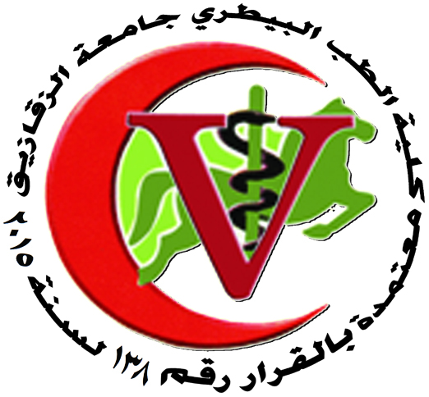 | 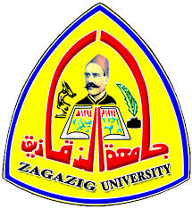
Zagazig University
Faculty Of Veterinary Medicine
Department Of Parasitology

- 1.Vet. Noha Hassan K. Aboda, Dept. of Parasitology, Faculty of Vet. Med. Zag. Univ., 26/10/2017 "
Studies on cryptosporidium species in cattle and camels.

2. PhD Thesis

1. Vet. Reham Gamal Abu Al Ela Anter, Dept. of parasitology, Faculty of Vet. Med. Zag. Univ., 10/12/2017, Parasitological and molecular studies on some endparasites in quails and pigeons.

Head of the department
Prof.Dr. AHMED IBRAHIM I. BADAWY

