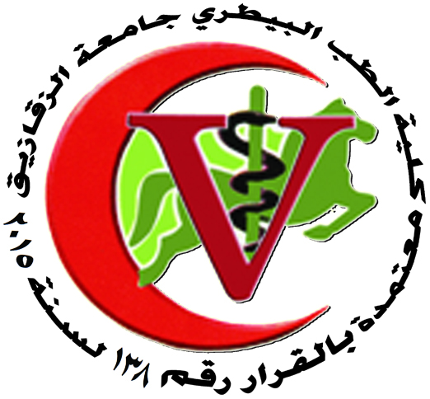 | 
Zagazig University
Faculty Of Veterinary Medicine
Department Of Zoonoses

Thesis Under Supervision:

Master Thesis Under Supervision:
- Asmaa Abo El abbas Hussei, Dept. of parasitology, Faculty of Vet. Med. Zag. Univ., December, 2014 “Studies on hydatid cysts in some animals ".

Head of the department
Prof.Dr. AHMED IBRAHIM I. BADAWY

