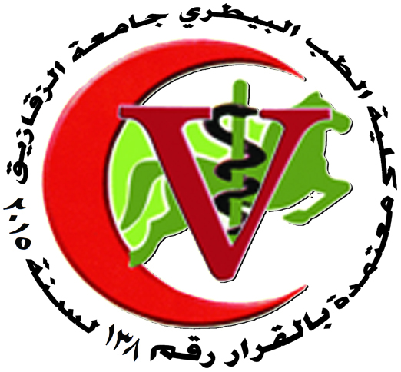
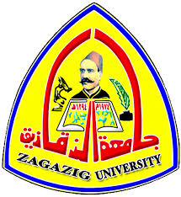

Zagazig University
Faculty Of Veterinary Medicine
Department Of Fish diseases and management

أولا: المشروعات البحثية التي شارك بها أعضاء هيئة تدريس بقسم امراض و رعاية الاسماك

First Scientific Project

Title: Epidemiological investigations on Helminth infestation of carp from commercial pond farms of Saxony, including considerations about fish eating birds. Time: 6 months during 2004/2005.
Place: Institute of Parasitology, Faculty of Veterinary Medicine, Leipzig University, Germany.
Fund: Funded by European Union and Ministry of Agriculture and Forestry of Saxony,
Germany.
Name of Department staff member shared in this project: Prof. Dr. Gamal
El-Nobi Ahmed, professor of Fish Diseases and Management and the Vice Dean
for Education and Student Affairs.
Second Scientific Project

Title: Improvement of nutritive value of some unconventional feedstuffs in fish ration.
Time: 6 months during 2007/2008.
Place: Fish Research Unit, Faculty of Veterinary Medicine, Zagazig University, Egypt.
Fund: Funded by Post-graduate Studies Sector, Zagazig University, Egypt.
Name of Department staff member shared in this project: Prof. Dr. Gamal
El-Nobi Ahmed, professor of Fish Diseases and Management and the Vice Dean
for Education and Student Affairs.

Third Scientific Project

Title: Investigating fish health following infections with mussel larvae.
Time: 3 months during 2012.
Place: Aquatic Systems Biology Unit, Department of Ecology and Eco-system Management, Technical University of Munich, Germany.
Fund: Funded by German Research Foundation (DFG) and Aquatic Systems Biology Unit, Technical University of Munich, Germany.
Name of Department staff member shared in this project: Prof. Dr. Gamal
El-Nobi Ahmed, professor of Fish Diseases and Management and the Vice Dean
for Education and Student Affairs.

Fourth Scientific Project

Title: Comparative studies for the production of tilapia fish monosex (male) with and
without the use of male hormones.
Time: 12 months during 2009/2010.
Place: Fish Research Unit, Faculty of Veterinary Medicine, Zagazig University, Egypt,
Egypt.
Fund: Funded by the Post-graduate studies sector, Zagazig University, Egypt. Name of Department staff member shared in this project: Dr. Rasha Mohamed Reda Mohamed, Assistant professor of Fish Diseases and Management Faculty of Veterinary Medicine, Zagazig University.

ثانيا: المشروعات البحثية التي تم داخل قسم امراض و رعاية الاسماك

First Scientific Project

Title: The use of probiotic to raise the rates of growth, immunity and resistance of
Oreochromis niloticus against diseases.
Time: 12 months during 2010/2011.
Place: Department of Fish Diseases and Management, Faculty of Veterinary Medicine,
Zagazig University, Egypt.
Fund: Funded by the Post-graduate studies sector, Zagazig University, Egypt.
Name of Department staff member Principle investigator of this project: Dr. Rasha Mohamed Reda Mohamed, Assistant professor of Fish Diseases and Management Faculty of Veterinary Medicine, Zagazig University.
Second Scientific Project

Title: Assessment of probiotics prepared from the intestine isolates in cultured fishes.
Time: 24 months during 2012/2013.
Place: Department of Fish Diseases and Management, Faculty of Veterinary Medicine,
Zagazig University, Egypt.
Fund: Funded by Science & Technology Development Fund, Ministry of State for
Scientific Research, Egypt.
Name of Department staff member Principle investigator of this project: Dr. Rasha Mohamed Reda Mohamed, Assistant professor of Fish Diseases and Management Faculty of Veterinary Medicine, Zagazig University.

