Curriculum Vita
Of
Dr. Essam A. Mahmoud

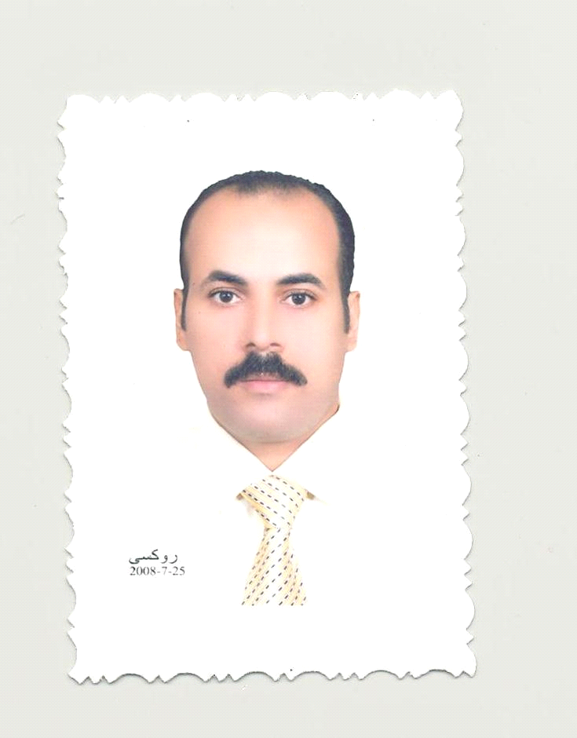
Current Post:
Lecturer of Clinical Pathology-
Faculty of Veternary Medecin-
Zagazig University

10/2014

A- Personal Data:
- Name : Essam A. Mahmoud.
- Nationality : Egyptian.
- Date of Birth : 27-8-1974.
- Place of Birth : SharKia- Egypt.
- Religion : Moslem.
- Current Posts : Lecturer of Clinical Pathology, Fac. Of Vet. Med., Zag. Univ.
- Marital Status: : Married with four children.
- Adresses
Residence : 15 El-maadawy street, Diarb Negm, Sharkia, Egypt.
E-Mail : essammahmoud97@yahoo.com
essammahmoud97@hotmail.com
essam_mahmoud@zu.edu.eg
essammahmoud97@gmail.com
- Telephones:
Residence: 0553776855.
Mobile :01157737882.
- Spoken Languages: Arabic and English both fluently.

B- Educational Background:
- Bvsc of Vet. Science (Intake 1997) with grade: Very Good.
- Master Degree (clinical pathology); 29-7-2002.
- PhD degree (clinical pathology): 5-2-2006

C- Posts Occupied:
- Assistant professor , King Khaled University from 2008 till 2013.
- Lecturer of Clinical Pathology from 28-3-2006. Zagazig University
- Ass. Lecturer of Clinical Pathology from 14-10-2002 till 28-3-2006.Zagazig University.
- Demonstrator of Clinical Pathology from 17-6-1998 till 14-10-2002.Zagazig University.
D- Training :
- Toefl from Amid East 2004.
- Course in University teaching.
- Three courses in applications of computer sciences.
- Course in course designer.
- Course in teaching assessments.
- Course in management of time and work stresses.
- Course in preparing, writing researches and their international publications.
- Course in how to use technology in teaching.
- Course in Electronic Learning.
E- Memberships:
- Membership of Egyptian veterinary medical Association.
- Membership of Comparative Pathology and Clinical Pathology Association.

F- Teaching Courses:
- Teaching the hematology, Clinical Chemistry and Urology (theoretical and practical) to the undergraduate students of the 4th year. Applying the requested work in the lab of the department of hematology.
- Teaching the basic course of Master degree of clinical pathology to post graduate students.
- Teaching the basic course of PHD of clinical pathology to post graduate students.
- Teaching of Clinical Enzymology (code: 86) to PHD students.
- Teaching and supervisor hours: 36 hours weekly.
G- Publications:
- Molecular And Immunological Studies On The Ameliorating Effect Of Conjugated Linoleic Acid Against The Harmful Effect Of Thermal Treated Oils In Rats. The Egyptian Journal Of Biochemistry And Molecular Biology. April 2007, 25(258-268).
- Clinicopathological Studies On The Effect Of Some Immunostimulants In Chickens. 9th Vet.Med.Zag. Conference. August 2008: 388-394.
- Effect Of Curcumin On Hematological, Biochemical And Antioxidants Parameters In Schistosoma Mansoni Infected Mice. International Journal of Sciences. March 2013, volume 2: 1-14.
- Biochemical and Clinicopathological Studies on Some Antihyperglycaemic Herbal Preparations in Alloxan Induced Diabetic Rats. Sch.J. App. Med. Sci., 2013, 1(2): 48-55.
H- Conferences:

1- المشاركة في مؤتمر الطب البيطري العربي الثلاثون بالجمعية الطبية البيطرية بالقاهرة في الفترة 12/14-5-2014
2- حضور مؤتمر الموارد الطبيعية والتنمية المستدامة بكلية العلوم –جامعة الزقازيق 25 يونيو 2014

3- المشاركة في المؤتمر العلمي الثامن بجامعة المنصورة بالتعاون مع جامعة هانوفر بالمانيا بشرم الشيخ في الفترة من 6/9-9-2014

I- Supervision of thesis: -

م | اسم الرسالة بالعربية | الرسالة باللغة الانجليزية | نوع الرسالة | اسم الطالب | التاريخ | الجهة
1 | دراسات باثولوجية اكلينيكية على بعض النباتات المدرة للبول | Clinicopathological studies on some diuretic plants | ماجستير | انجى محمود عبدالمجيد | 10/2011 | جامعة الزقازيق
2 | دراسات باثولوجية إكلينيكية على بعض النباتات المستخدمة كوقاية للكبد ضد التسمم الكبدي المحدث بالبارسيتامول. | Clinicopathological studies on certain plants used as as hepatoprotective against paracetamol induced hepatotoxicity | دكتوراه | غاده ابراهيم  عبدالرحمن | 10/2011 | جامعة الزقازيق
3 | دراسات باثولوجية إكلينيكية على تاثير صمغ النحل ولقاح الباستيريلا في الارانب | Clinicopathological studies on the effect of propolis and pasteurella vaccine in rabbits | دكتوراه | محمد فرج محمد  مارس 2014 | 10/2013 | جامعة الزقازيق
 | دراسات باثولوجية إكلينيكية على تأثيرالخرشوف في العطب الكبدي. | Clinicopathological studies on the effect of  artichoke on hepatic damage | ماجستير | اسراء هاني محمد | 4/2014 | جامعة الزقازيق

