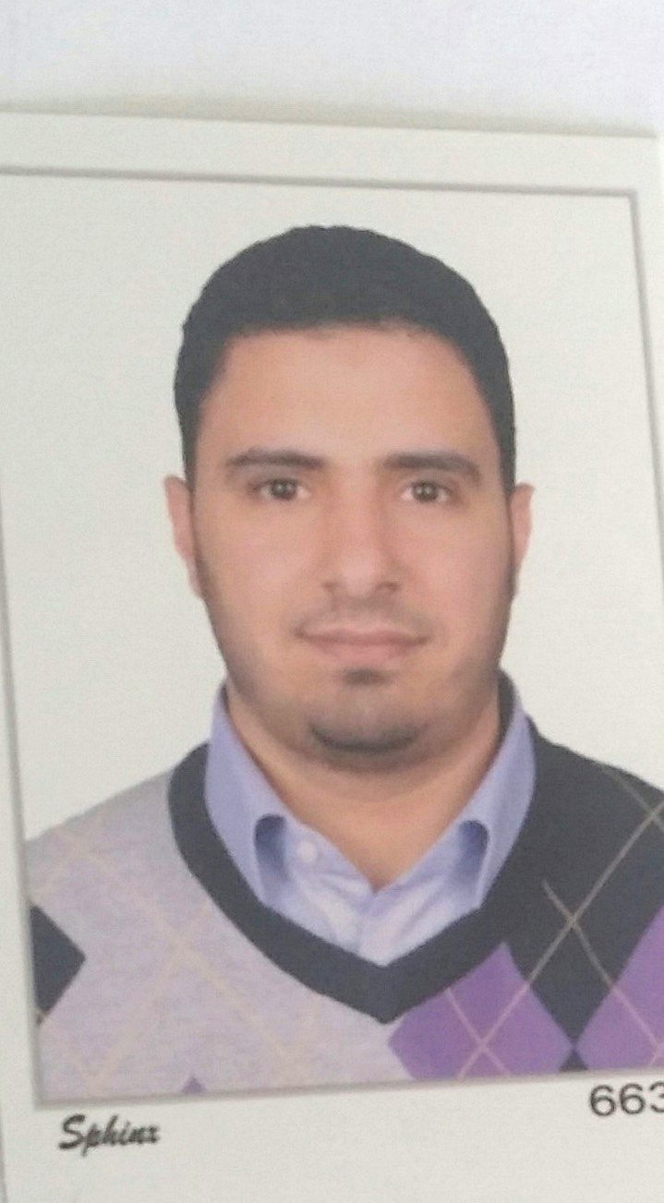

Curriculum Vitae
Abd- El Hakeem Ibraheem Elmor

Professional Profile
In 2011, I got a PhD in Fish Diseases and management.
I’m willing to continue my research oriented career in the same field.

Personally

Nationality: | Egyptian
Year of birth: | 25/10/1981
Languages: | Arabic: | Mother tongue
 | English: | Very good spoken and written.  Local TOFEL+ two courses in the American University Centre in Egypt
 | French: | Basic knowledge
Address: | Zagazig . hai el zohor el jamaa st.
E-mail: | hakimelmor@Gmail.com
Tel: | 002-0193333308

Education

Period: | Type of education: | Name of school: | Degree:
1998 – 2003 | B.Sc. of Veterinary Medical Science | Zagazig University, Egypt | Very good with honor degree
2004-2007 | Master of Vet. Medical Science | Zagazig University, Egypt | Excellent
2007-2011 | PhD of Vet. Medical Science | Zagazig University, Egypt | Excellent

Thesis of Phd: | “further Studies on the effect of some stress factors and feed additives on health, growth and immunological functions of common cultred fishes”
Courses: for example | - Fish diseases and management.  - Animal and poultry feeding and malnutrition diseases.  - Essentials of nutrition.  - Fish feeding. and formulation  - Pharmacology (chemotherapy). | Zagazig university  Egypt
 | - Fish pathology course.(as audit)  - Advanced nutrition course.(as audit)  - Aquaculture course.(as audit) | University of Guelph  Canada
 | - Scientific Research Methodology | Zagazig university  Egypt
 | - Decision and Problem Solving | Zagazig university  Egypt
 | - Thinking skills course | Zagazig university  Egypt
 | - Effective communication skills | Zagazig university  Egypt

Job Experiences
 | Department of fish management and Diseases
Period: | From 2003-2010
occupation: | Demonstrator (TA) and asistant lectrurer and lecturer
Activities: | *Giving practical sections for 4th year B.sc. students on the aqua culture management  *Giving practical sections for 4th year B.sc. students on: diagnosis of fish disease  *Giving practical sections for 4th year B.sc. students on: fish pathology  *Giving practical sections for 4th year B.sc. students on: treatment of fish  *Grade examination, Lab reports  *Preparing analytical lab material  * Assist in preparation & invigilation of exam  * Perform routine & post-mortem exam to fish  *Diagnose diseases or abnormal conditions  *Treat sick fish by prescribing

ICT Knowledge

Operating systems: | Windows 98, windows 2000, Windows XP, vista.
Specific software & tools: | - Microsoft Word  - Microsoft Excel  - Microsoft Outlook  - Microsoft Powerpoint

Skills, personality and hobbies

Not mentioned skills: typing blindly and fluently  Personality/assets:  * Critical.  * Sense of humor.  * Looking at the result.  * Communicative / deliberative.  * Exacting. | Hobbies:  * Sport: cycling, football & tennis.  * Making excursions with friends.  * Film.  * Cooking.  * Internet.  * Reading articles about health and other  Concerns.  * Quiz.

scientific visits:

I had a scientific visit to Fish Nutrition Lab in Animal and poultry Science Department in Guelph University, Canada to complete research under super vision of Dr.Dominique Bureau for 9 months

experiences with equipments and techniques:

-Immunology and Biochemistry: I was trained with Dr. shyan immunity Lab. in (OVC) Guelph university,Canada for three months
-Histology and pathology: I have a moderate knowledge with the histology and pathology of
Fish including sampling .staining and microscopical examination of the slide

-Sample collection: Blood, oral, cloacal and vaginal swabs, organs, tumors and observing and handling chickens and blood collection from fish
-Fish pathology: good experience with clinical examination and postmortem watching for fish with prescription of medication
-Fish nutrition :including feed formulation and analysis of the diets (ash, protein, lipid, gross energy ) and feeding of fish and management of fish inside the tanks

workshops and seminars:
Participating in many seminars and workshops for example
- Fish work shop (university of Guelph, Canada )
- Laboratory animals handling (zagazig university,Egypt)
- Real time PCR work shop(University of Guelph, Canada)

membership or association with organizations :
- *The veterinary surgeons Syndicate
*Member in "Life Makers ".
- *General organizer of Elwafa club : A campus club based society with various community oriented activities
- Member of Quality Assurance and Accreditation project , Faculty of Veterinary medicine ,Zagazig University, Egypt

- *General organizer of ahla haia club : A campus club based society with various community oriented activities

publications :

plus master and PhD I had Published

- Jamie M. Hooft a, Abd El Hakeem Ibraheem Elmor a,1, Pedro Encarnação b, Dominique P. Burea u" a Rainbow trout (Oncorhynchus mykiss) is extremely sensitive to the feed-borne
Fusarium mycotoxin deoxynivaleno (DON)2011 " Aquaculture 311 (2011) 224–232

- El-Bouhy Z , El-Nobi, G and El-Murr. A Department of Fish Diseases and Management ,
Faculty of Vet. Medicine, Zagazig University" Effect of Aflatoxicosis And Different Antimycotoxins On Health And Growth Of Oreochromis Niloticus".
1

- El-nobi,G;Saleh,G;El-Eraky,w. and Elmurr,A. {effect of sodium cyanide toxicity on health and growth of oreochromis niloticus} zag.Vet.J.(ISSN.1110-1458) Vol.36,No 4(2008)pp.57-64

Eleraky Wafaa, Ibrahim 1 1 Doaa, 2El-Murr, A. and 1Mahmoud RaniaEffects of Dietary Inclusion of Black Cumin Seeds, Green Tea and Propolis Extraction Growth Parameters, Body Composition and Economic Efficiency of Nile Tilapia, Oreochromis niloticus

Mohamed El-Sayed, Hakim, Y and El-Murr, A Effects of different growth promoters as feed supplement on growth and immune response in Oreochromis niloticus Egyptian Journal for Aquaculture Vol. 2 No.3 2012

Shimaa A Elgaml1*, Ryad Khalil2, Emad A Hashish1 and Abdelhakeem El-Murr3 Protective Effects of Selenium and Alpha-Tocopherol against Lead- Induced Hepatic and Renal Toxicity in Oreochromis Niloticus J Aquac Res Development Volume 6 • Issue 1 • 1000299

- I had abstract in the World Aquaculture Society conference which had been in San Diego ,USA in March.2010

References
Available upon request

