CURRICULUM VITAE
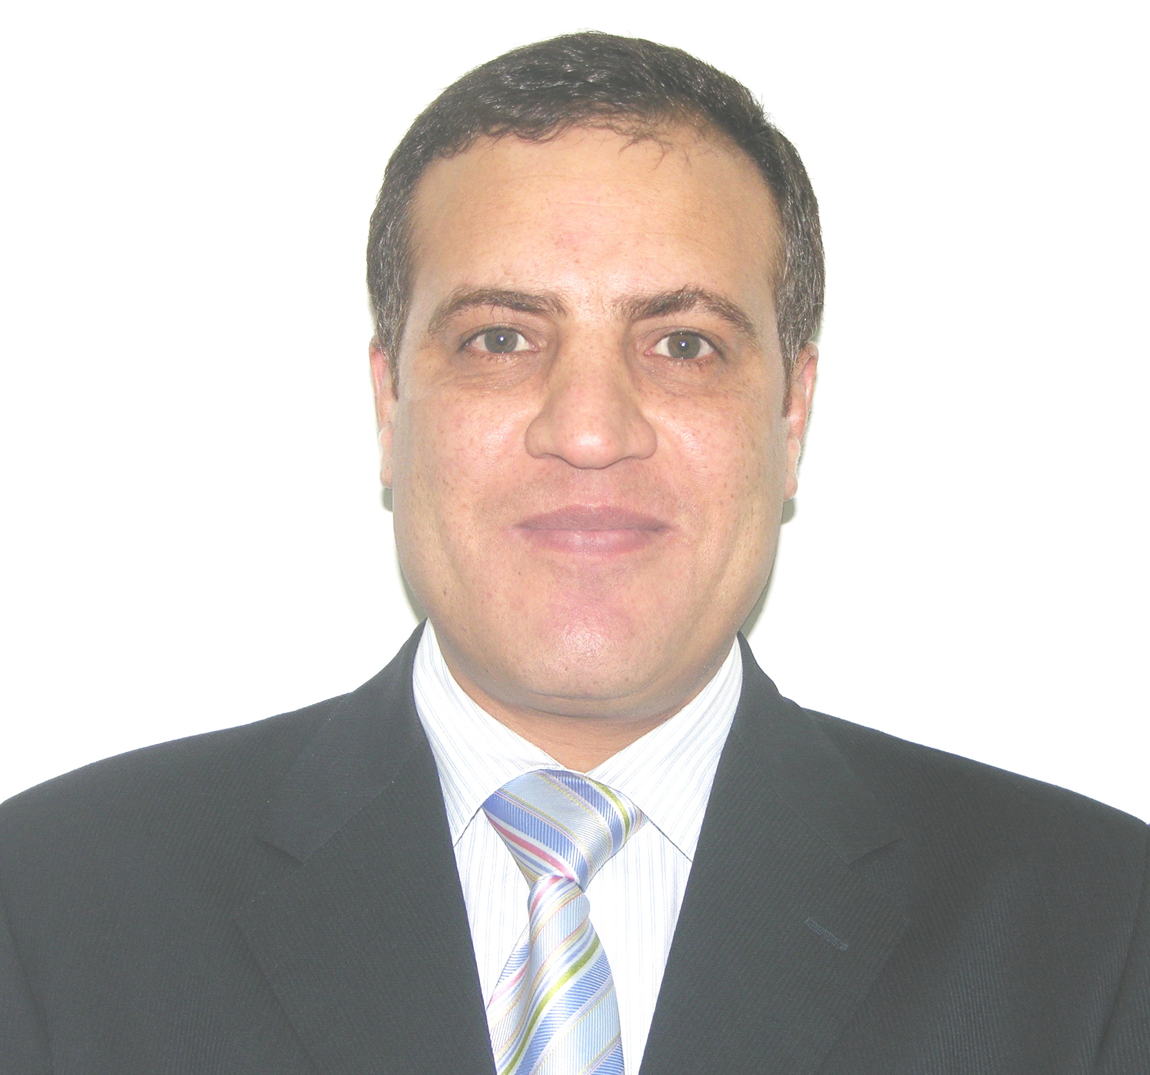

Personal Information:
Name: Dr. Kamel Abdel-Rahim Metwally, Ph.D

Present position: Assistant Professor of Medicinal Chemistry, Faculty of Pharmacy, Zagazig University, Zagazig, Egypt..

Home address: Al-SHymaa Street, Al-Salam District, Zagazig.

Work Address: Department of Medicinal Chemistry, Faculty of Pharmacy, Zagazig University, Egypt.

Telephone: +20-55-2303266 (Work)
+20-1014992285 (Mobile)
Fax: +20-55-2303266

Email: kametwally@hotmail.com

Date of Birth: December 27, 1965.
Place of Birth: Sharkia, Egypt.

Marital Status: Married, two kids.

Citizenship: Egypt.

Education:
Ph.D. 1998: Medicinal Chemistry, Virginia Commonwealth University (USA) according to a channel program with Zagazig University (Egypt).
Title of dissertation: “Design and synthesis of novel 5-HT₂ ligands”.

M.Sc. 1995: Medicinal Chemistry, Faculty of Pharmacy, Zagazig University.
Title of thesis: “Synthesis and pharmacological study of some new arylpropionic acid derivatives”.

B.Sc. 1990: Pharmaceutical Sciences, Faculty of Pharmacy, Zagazig University. “Excellent with honor degree; the first out of ~ 150 students”.

Teaching Experience:
- Medicinal Chemistry-1 course.
- Medicinal Chemistry-2 course.
- Medicinal Chemistry-3 course.
- Drug Design course.
- Organic Chemistry-1 course.
- Organic Chemistry-2 course.
- General Chemistry course.
- Pharmacy Law and Ethics course.

Vocational Experience:
- Assistant Professor of Medicinal Chemistry, Faculty of Pharmacy, Zagazig University, Zagazig, Egypt, July 2012- to date.
- Associate Professor of Medicinal Chemistry, College of Clinical Pharmacy, King Faisal University, KSA, September 2006- July 2012.

- Associate Professor of Medicinal Chemistry, Faculty of Pharmacy, Zagazig University; September 2007- to date.

- Assistant Professor, Department of Medicinal Chemistry, Faculty of Pharmacy, Zagazig University; October 2001- August 2007.

- Visiting Lecturer; School of Pharmacy, Misr International University (MIU), Cairo, Egypt; September 2003 to September 2005.

- Visiting Scientist, Department of Medicinal Chemistry, School of Pharmacy, Medical College of Virginia, Virginia Commonwealth University, Virginia, USA; October 2000- October 2001; funded by the American university.

- Assistant professor, Department of Medicinal Chemistry, Faculty of Pharmacy, Zagazig University; October 1998- October 2000.

- Teaching Assistant; Department of Medicinal Chemistry, Faculty of Pharmacy, Zagazig University; April 1998 - October 1998.

- PhD research scholar at the School of Pharmacy, Medical College of Virginia, Virginia Commonwealth University, Virginia, USA; April 1996 to April 1998.

- Teaching Assistant; Department of Medicinal Chemistry, Faculty of Pharmacy, Zagazig University; March 1995- April 1996.

- Instructor; Department of Medicinal Chemistry, Faculty of Pharmacy, Zagazig University; 1990- 1995.

Reviewing and refereeing:
Have been invited to review many articles for the following journals:
- European Journal of Medicinal Chemistry.
- Bioorganic and Medicinal Chemistry.
- Archiv der Pharmazie.
- Molecules.
- Letters in Organic Chemistry.
- Mini-Reviews in Medicinal Chemistry.
- Monatshefte fur Chemie.
- Letters in Drug Design and Discovery – Online.
- Journal of Enzyme Inhibition and Medicinal Chemistry – ScholarOne.
- Journal of Heterocyclic Chemistry.

Academic Activities:
- Member, Scientific Council of King Faisal University (April 2010 – to date).
http://www.kfu.edu.sa/ar/Departments/Scientific-Council/Pages/Oedaoualcilsalalmi.aspx
- Member, Translation, Authorship and Publication Center of King Faisal University (January 2010 – to date).
http://www.kfu.edu.sa/ar/Centers/Translate/Pages/Directors-Center.aspx
- Member, KFU University Committee of Scientific Chairs (February 2012 – to date).
- Member, Quality Assurance Unit (February 2012 – to date).
- Member, KFU University Committee for Preparation of Course Descriptions for Health Track Preparatory Year (October 2011 – January 2012).
- Member, Main Committee for Preparation of College Self Study (April 2011 – to date).
- Member, Strategic Plan Committee ( January 2012 – to date).
- Chair, Interviews Committee, College of Clinical Pharmacy, King Faisal University (Sep. 2009 – to date).
- Chair, Research, Laboratories and Academic Textbooks Committee, College of Clinical Pharmacy, King Faisal University (Sep. 2007 – to date).
- Member, Activities Committee, College of Clinical Pharmacy, King Faisal University (Dec. 2006 – Dec. 2009).
- Member, Academic Affairs Committee, College of Clinical Pharmacy, King Faisal University (Dec. 2006 – Dec. 2008).
- Member, Quality Office, College of Clinical Pharmacy, King Faisal University (Sep. 2008 – Sep. 2009).
- Member, Committee of Society Service and Environment Development, Faculty of Pharmacy, Zagazig University (Dec. 2001 – Aug. 2006).
- Member of the American Chemical Society.
- Member of the Egyptian Pharmaceutical Society since 1990.
- Member of the Egyptian Syndicate of Pharmacists since 1990.

Conferences and Workshops:
- Workshop: "Preparation of University Instructors", College of Education, Zagazig University, Egypt (April 1995).
- Invited Speaker, Proceedings of the 75th Annual Meeting of the Virginia Academy of Science, Virginia Polytech Institute and State University, Blacksburg, Virginia, USA (May, 1997).
- Workshop: "Research Methodology", College of Education, Zagazig University, Egypt (January 2005).
- Workshop: "Course Design", College of Education, Zagazig University, Egypt (March 2006).
- Invited Speaker, Proceedings of the 7th Saudi International Pharmaceutical Conference, Rhiadh, KSA (March, 2007).
- Conference: "2nd Quality Conference", King Faisal University, Al-Khobar, KSA (May, 2007).
- Workshop: "Basics of Career Development for University Professors", Taibah University, Al-Madinah Al-Munawwarah, KSA (May 2007).
- Workshop: "Strategies of University Student Learning", Taibah University, Al-Madinah Al-Munawwarah, KSA (May 2007).
- Workshop: "Developing Thinking Skills", Taibah University, Al-Madinah Al-Munawwarah, KSA (May 2007).
- Workshop: "Strategies of University Teaching", Taibah University, Al-Madinah Al-Munawwarah, KSA (May 2007).
- Workshop: "The Use of Technology in Teaching", Faculty and Leadership Development Project (FLDP), Zagazig University (August 2007).
- Workshop: "Credit Hours System", Faculty and Leadership Development Project (FLDP), Zagazig University (August 2007).
- Workshop: "Strategic Planning", Faculty and Leadership Development Project (FLDP), Zagazig University (August 2007).
- Workshop: "Examination System and Student Assessment", Faculty and Leadership Development Project (FLDP), Zagazig University (August 2007).
- Conference: "2nd Riyadh International Dental & Pharmacy Meeting", Inter-Continental Hotel, organized by Riyadh college of Dentistry and Pharmacy, Riyadh, KSA (November 2007).
- Workshop: "Basic WebCT", Innovation Development and Excellence Project, Deanship of Higher Education Development, King Faisal University, Al-Ahsa Inter-Continental Hotel, KSA (March 2008).
- Workshop: "Preparation of Electronic Exams Using WebCT", Innovation Development and Excellence Project, Deanship of Higher education Development, King Faisal University, Al-Ahsa Inter-Continental Hotel, KSA (March 2008).
- Workshop: "Teaching Strategies for University Students" Innovation Development and Excellence Project, Deanship of Higher education Development, King Faisal University, Al-Ahsa Inter-Continental Hotel, KSA (March 2008).
- Workshop: "Business Administration Department Experience in Achieving Learning Objectives and Self Assessment", College of Management, King Faisal University, KSA (April 2008).
- Workshop: "The First Self Evaluation Report for Quality Assurance", College of Clinical Pharmacy, King Faisal University, KSA (April 2008).
- Workshop: "Programs for Quality Control, Quality Assurance and Accreditation Measurements", College of Science, King Faisal University, KSA (May 2008).
- Trainer, Workshop "Basic WebCT", Computer Room, College of Clinical Pharmacy, King Faisal University, KSA (October 2008).
- Trainer, Workshop " Preparation of Electronic Exams Using WebCT", Computer Room, College of Clinical Pharmacy, King Faisal University, KSA (October 2008).
- Trainer, Workshop, Videoconference to Female Section, "Basic WebCT", Computer Room, College of Clinical Pharmacy, King Faisal University, KSA (November 2008).
- Scientific sessions, "2nd Medical Profession Day", College of Medicine, King Faisal University, Dammam, KSA (April 2008).
- Conference: "Taiba International Chemistry Conference", Madina Meridien Hotel, Faculty of Science, Taibah University, Al-Madinah Al-Munawwarah, KSA (March 2009).
- Participant, Proceedings of the 8th Saudi International Pharmaceutical Conference, Rhiyadh, KSA (April 26-28, 2010).
- Workshop, Nuclear Magnetic Resonance for Pharmacists, workshop organized by the Saudi Pharmaceutical Society, Riyadh, KSA (April 27, 2010).
- Workshop: "Skills and Tools of "Blackboard" Electronic Learning System", Innovation Development and Excellence Project, Deanship of Higher Education Development, King Faisal University, Al-Ahsa Inter-Continental Hotel, KSA (May 1-3, 2010).
- Speaker, "Drugs of abuse", Al-Ahsa Police Department, Al-Ahsa, Kingdom of Saudi Arabia (February 16, 2011).
- Participant, "KACSt-Saudi University Meeting", King AbdulAziz City for Science and Technology (KACST), Riaydh, Kingdom of Saudi Arabia (March 30, 2011).

Honors and Awards:
- The First of Class Honor (1990): Faculty of Pharmacy, Zagazig University.
- Egyptian Syndicate of Pharmacists Award for distinguished academic pharmacists (1995).
- Egyptian Syndicate of Pharmacists Award for distinguished academic pharmacists (1999).
- Zagazig University Research Award for distinguished researchers (2007).
- Zagazig University Research Award for distinguished researchers (2009).

Instrumentation:
Catalytic hydrogenators, IR and NMR spectrometers, spectrophotometers, optical polarimeters.

Computer Software:
Windows XP, MS word, MS Excel, MS Powerpoint (presentation design), WebCT, Blackboard, Banner, SciFinder Scholar, Chemdraw, Chemsketch, NMR simulation, Chem3D, ACDLogP calculations, statistics programs like SMAC and Curve Expert.

Publications:
- El-Sadek, M., Abdel Aziz, L., and Metwally, K. Synthesis and biological activity of certain flurbiprofen derivatives. Zagazig J. Pharm. Sci., 5, 29-35 (1996).
- El-Sadek, M., Abdel-Aziz, L., Abou-Kull, M., and Metwally, K. Synthesis and biological evaluation of novel heterocyclic derivatives of flurbiprofen.; Zagazig J. Pharm. Sci., 7, 94-100 (1996).
- Metwally, K., Dukat, M., and Glennon, R. Azaspirodecanones: structure-affinity relationships for 5-HT_{2A} serotonin receptor binding. Virginia J. Sci., 48, 141 (1997).
- Metwally, K., Dukat, M., Egan, C., Smith, C., DuPre, A., Gauthier, C., Herrick-Davis, K., Teitler, M., and Glennon, R. Spiperone: influence of spiro ring substituents on 5-HT_{2A} serotonin receptor binding. J. Med. Chem., 41, 5084-5093 (1998).
- Lashine, E., El-Adl, S., Metwally, K., and Abou-Kull, M. Synthesis of some new quinoline derivatives of potential antimicrobial activity. Zagazig J. Pharm. Sci., 8, 23-27 (1999).
- El-Adl, S., Metwally, K., and Abou-Kull, M. Utility of dichloromaleimide derivative as a chromogenic reagent for the spectrophotometric determination of certain fluoroquinolones and related compounds. Zagazig J. Pharm. Sci., 8, 13-17 (1999).
- Glennon, R., Metwally, K., Dukat, M., Ismaiel, A., De Los Angeles, J., Herndon, J., Teitler, M., and Khorana, M. Ketanserin and spiperone as templates for novel serotonin 5-HT2A antagonists. Curr. Top. Med. Chem., 539-558, 2, (2002).

- Sukkar, O., Metwally, K., Abu Koll, M. and El-Adl, S. Increasing sensitivity of colorimetric determination of basic drugs through ion pair complex formation. Zagazig J. Pharm. Sci., 14, 32-39 (2005).
- Metwally, K., Abdel-Aziz, L., Lashine, E., Husseiny, M. and Badawy, R. Hydrazones of 2-arylquinoline-4-carboxylic acid hydrazides: synthesis and preliminary evaluation as antimicrobial agents. Bioorg. Med. Chem., 14, 8675-8682 (2006).
- Metwally, K., Yaseen, S., Lashine, E., El-Fayomi, H. and El-Sadek, M. Non-carboxylic analogues of aryl-propionic acids: synthesis, anti-inflammatory activity and ulcerogenic potential. Eur. J. Med. Chem., 42, 152-160 (2007).
- Metwally, K., Pratsinis, H., and Kletsas, D. Pyrimido[4,5-c]quinolin-1(2H)-ones as a novel class of antimitotic agents: synthesis and in vitro cytotoxic activity. Eur. J. Med. Chem., 42, 344-350 (2007).
- Metwally, K., Aly, O., Aly, E., Banerjee, A., Ravindra, R. and Bane, S. Synthesis and biological activity of 2,5-diaryl-3-methyl-pyrimidino[4,5-c]quinolin-1(2H)-one derivatives. Bioorg. Med. Chem., 15, 2434-2440 (2007).
- Metwally K., Aly, E., Aly, O. and El-Nabtity S. Spirohydantoins derived from 1-tetralone: design, synthesis and exploration of their anticonvulsant activity and neurotoxicity. Bull. Fac. Pharm. Cairo Univ., 45, 149-154 (2007).
- Metwally K., Khalil A., Pratsinis, H., Kletsas, D. Antimitotic pyrimido[4,5-c]quinolin-1(2H)ones: synthesis, in vitro cytotoxicity and a structure-activity relationship investigation. Arch. Pharm., 43, 465-72 (2010).
- Metwally K., Khalil A., Pratsinis, H., Kletsas, D, Asmaa Sallam, Khalid El-Sayed. Structure-activity relationship investigation of methoxy substitution on anticancer pyrimido[4,5-c]quinolin-1(2H)-ones. Medicinal Chemistry Research, in press.

Invited presentations:
  - Azaspirodecanones: structure-activity relationships for 5-HT_{2A} serotonin receptor binding. Proceedings of the 75th Annual Meeting of the Virginia Academy of Science, May 20-23, 1997, Virginia Polytech Institute and State University, Blacksburg, Virginia, USA.
  - New safer anticonvulsants. Proceedings of the 7th Saudi International Pharmaceutical Conference, March 20, 2007, Rhiadh, KSA.
  - Drug discovery: serendipity and nature inspiration. Gwatha Hall, King Faisal University, Hufof city, Al-Ahsa.

Funded grant proposals:
- Principal Investigator, KFU Deanship of Scientific Research grants 2009-2010: Grant number (10032/2009), fund: 97,000 SR, finished.
- Principal Investigator, KACST (King Abdul-Aziz City for Science and Technology) grants 2010-2011: Grant number (APR-30-233), fund: 911,000 SR, approved for funding).
- Co-Investigator, KFU Deanship of Scientific Research grants 2010-2011: Grant number (110033/1431), fund: 167,000 SR, underway).

Reference names:
- Dr. Richard A. Glennon, Professor and Chairman of Medicinal Chemistry Department, School of Pharmacy, Medical College of Virginia-Virginia Commonwealth University, USA.
Email: glennon@vcu.edu.
- Dr. Mohamed El-Sadek, Professor and Chairman of Medicinal Chemistry Department, and vice Dean, Faculty of Pharmacy, Zagazig University, Zagazig, Egypt.
Email: el-hussainy@hotmail.com
- Dr. Malgorzata Dukat, Professor of Medicinal Chemistry, School of Pharmacy, Medical College of Virginia-Virginia Commonwealth University, USA.
Email: mdukat@vcu.edu
- Dr. Abdul-Aziz Al-Mulhim, Vice President of King Faisal University for Postgraduate Studies and Scientific Research, Al-Ahsa, KSA.
Email: aalmulhem@kfu.edu.sa
- Dr. Ahmed Al-Shoabi, Vice President of King Faisal University for Development and Community Service, Al-Ahsa, KSA.
Email: aalshoaibi@kfu.edu.sa

