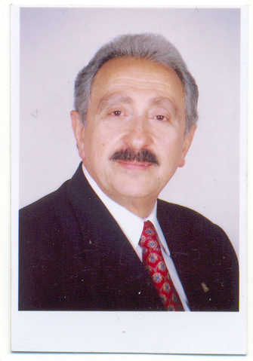

Name: Dr. Mohamed Shawky Ahmed Shawky

Birth Date: 1942

Nationality: Egyptian

Marital Status: Married

Qualifications:

B.Com degree in Bus. Adm., Faculty of Commerce, Ain Shams University, Cairo-Egypt, 1962.

Master in Bus. Adm. (MBA) Faculty of Commerce, Cairo University, Cairo-Egypt, 1970.

Philosophy Doctor in Bus. Adm. (Ph.D.) Faculty of Commerce, Cairo University, Cairo-Egypt, 1977.

Other Qualifications:

Certificate of completion for the policies of regional planning and technological development (Institute of Planning and Economic Development (I. DEP) Dakar-SENEGAL).

Certificate of completion for the international programs held by the American government in association with other governments and the Department of Social Welfare (Wharton School – University of Pennsylvania – Philadelphia, U.S.A. – 1978).

Present Occupation:

Previous Dean of the Faculty of Commerce – Zagazig University – Egypt, since 1996.

Previous Occupation:

Vice Dean for Graduate Studies, 1995.

Chairman of Bus. Admin. Dept., Faculty of Commerce, Zagazig University, 1988.

Professor of Bus. Admin., Faculty of Commerce, Zagazig University, 1985.

Associate Professor of Business Admin. 1980.

Lecturer in Bus. Adm. Dept., Faculty of Commerce, Zagazig University 1977.

Expert in Social and Cultural Planning, The Institute of National Planning (I.N.P.) Cairo, Egypt, 1970.

Instructor of Bus. Adm. Faculty of Commerce, Cairo University, 1962-1969.

Experience:

Participating and organizing several training programs such as:

Supervisory and Managerial Skills Development

Problem Solving and Decision Making (Arabic & English)

Quantitative Methods in Decision Making

Negotiation Skills Development (Arabic & English)

Marketing, which includes?

Bank Marketing

Strategic Marketing

Salesmen Skills Development

Financial Marketing

Material Management (Purchasing and Warehouse) (Arabic & English)

Feasibility Studies

Administrative Communication

Strategic Planning

Inventory Control (Arabic & English)

Reporting and Conference Organization

Negotiations, Conferences and Meetings (Arabic & English)

Developing Training and Managerial Skills

How to be a successful sales manager?

Developing Dealing with Customers Skills

Situational Leadership Skills (English)

Strategic Thinking

Presentation skills (English)

Team Building (English)

Effective Presentation, Time management, Meeting Management

Effective Leadership

Effective Supervision Skills

Time Management and Decision Making

Conference Management

Creative Thinking

Problem Solving & Creative Decisions

Stress Management

Self & Time Management for Manager

Globalization and its effect on Management

The lists below are the corporations for which training programs were held:

The Egyptian National Bank

The Misr Bank

The Industrial Arab Organization

Business Administration Association in Cairo

Civil Service Department

AFMMEMCO International Ltd. Greece – Cyprus

Management Consulting Center (M.C.C.)

Marketing and Management Consulting Center (M.M.C.C.)

Professional Management Expertise Center (PMEC)

Chamber of Commerce (Jeddah – KSA)

Chamber of Commerce (Dammam – KSA)

Chamber of Commerce (Riyadh – KSA)

Chamber of Commerce (Abha – KSA)

Chamber of Commerce (Taif – KSA)

Bahrain Municipality

Abu Dhabi Municipality (Training Center)
- Police Headquarters (Training Center) – Dubai

- Police Headquarters (Training Center) – Abu Dhabi Governorate

Career Development Center (C.D.C.)

Institute of Banking and Financial Studies (U.A.E.)

Institute of Public Education (I.P.E.) Kuwait

National Consulting Bureau (N.C.B.) Kuwait

Saudi Yanbu Petrochemical Co. (Yanpet)

Management and Information Systems Consultants (Datamation)

Languages:

Arabic (fluent)

English (fluent)

French (fluent)

Books:

Basics of Business Administration

Production management

Modern Administration of Purchasing and Warehousing

Basic of Marketing

Personnel Management

Human Resources Management

